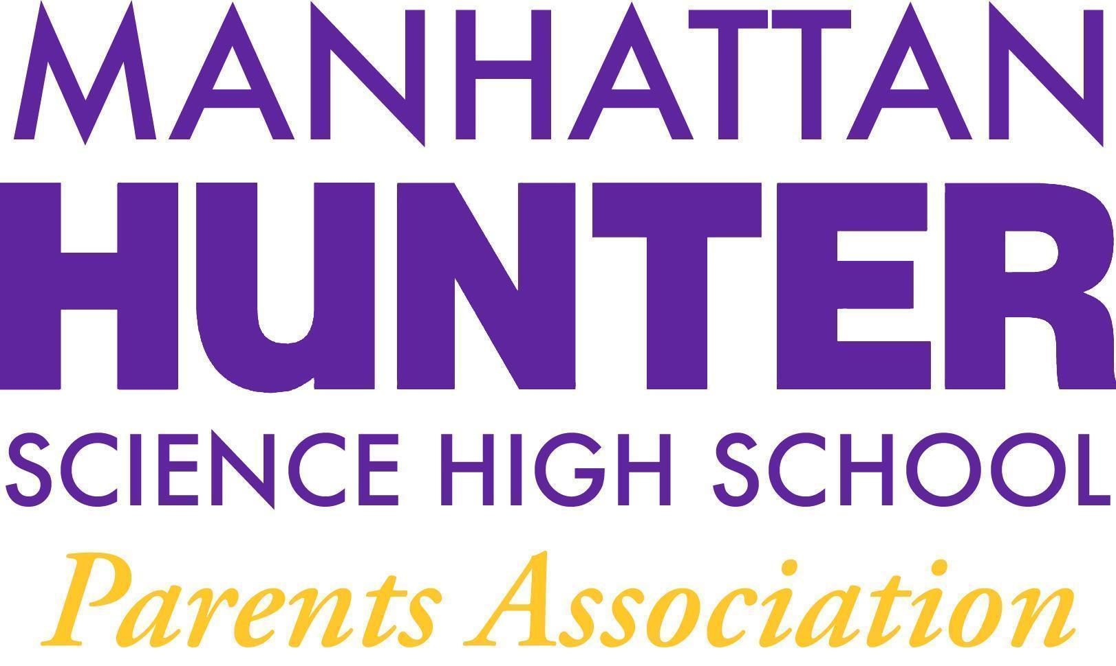
AGENDA
Manhattan Hunter Science High School Parents Association
General Membership Meeting
Tuesday, March 22, 2022
08:30am (Via Zoom)

- Meeting call to Order
- February 2022 Minutes Approval
- Monthly Financials Review
  - Income and Bank balance $33,168
    - Pending
      - -$540 (Instacart/Snacks)
      - +$1,500 (Company Match)
  - Upcoming/Recent Expenses
    - Empowerment Groups ($70 per meeting)
    - Mixers ($800 per meeting)
    - Data Team lunch and Care packages for teachers ($250/$650)
    - Upcoming:
      - snacks for clubs ($300)
      - break bread together afterschool ($750)
    - Flowers for hallways ($500)
- PA Announcements
  - Spring/March 31 Newsletter
    - Ukraine/Russia
    - SAT/PSAT
  - Bathroom Beautification Committee
  - DOE Parent Survey 2022 - March 25th
  - Vending Machine Research Committee
  - Homecoming/End of Year Celebration - Senior Symposium
  - Website Design Committee - parent, student and teacher input
- Q&A with Dr. Froner

