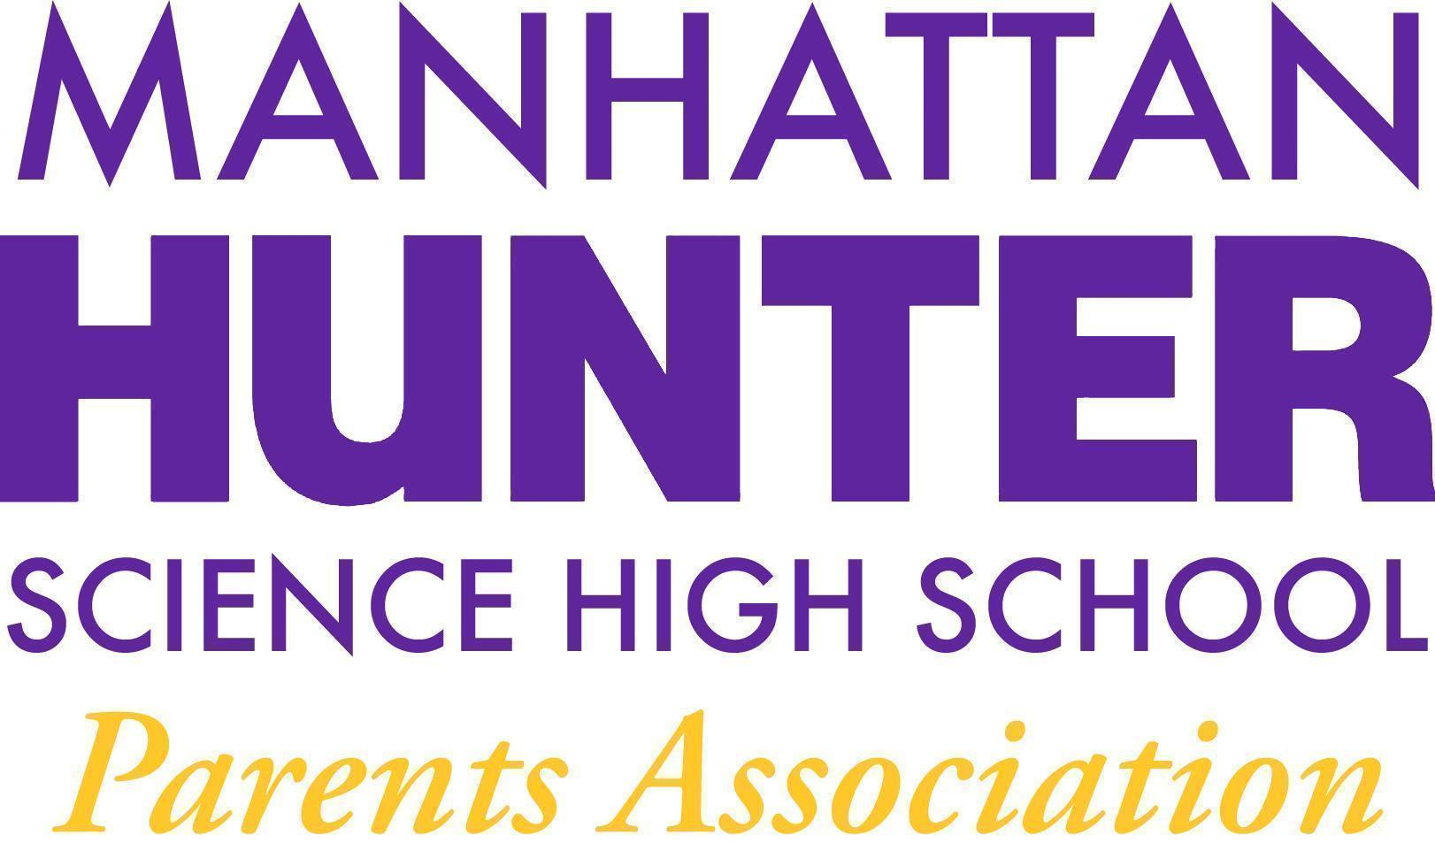
AGENDA
Manhattan Hunter Science High School Parents Association
General Membership Meeting
Tuesday, May 17, 2022
08:30am (Via Zoom)

- Meeting call to Order
- April 2022 Minutes Approval
- 2022/2023 PA Executive Board Election/Slate Ratification (see below)
- Monthly Financials Review
  - $3,000 - additional funds approval (membership - vote)
- PA Announcements
  - SLT Election - June 2022
  - Ukraine/Russia Supplies Giving
  - Financial Literacy Course Update
  - Bathroom Beautification Committee (and Vaping) Update
  - Website Design Committee
- Q&A with Dr. Froner

Executive Board - Slate - 2022/2023
Heather Tait - President
Barry Daub - VP (Hunter College Liaison)
Shari Hoenig - VP
Kristen Berger - Recording Secretary
Rachel Spiers - Treasurer

