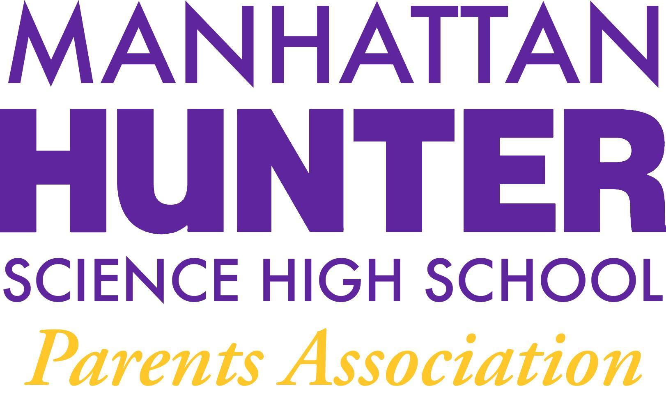
AGENDA
Manhattan Hunter Science High School Parents Association
General Membership Meeting
Tuesday, November 9, 2021
8:30-9:30pm (Via Zoom)

- Meeting call to Order
- Approval October 2021 Minutes
- November 2021 Financials Review
  - PA Debit card
  - Federal Taxes filing -11/15/2021
  - Upcoming Expenses
    - Gershon Retirement Party (food and beverage) $400
    - Class Mixers (food and beverage) $5,600/$6,500
    - Skateboard Rack $800
    - Keyboards/Instruments $1,000
    - Xmas party (food and beverage) $1,000
- PA Announcements
  - Botany Club Update (picture) and Amazon Smile Reminder
  - “From Thanks to Love” – November to February Giving Campaign
  - Website design and parent and teacher input
  - Spring Fling! (Online Auction)
- Q&A with Dr. Froner

