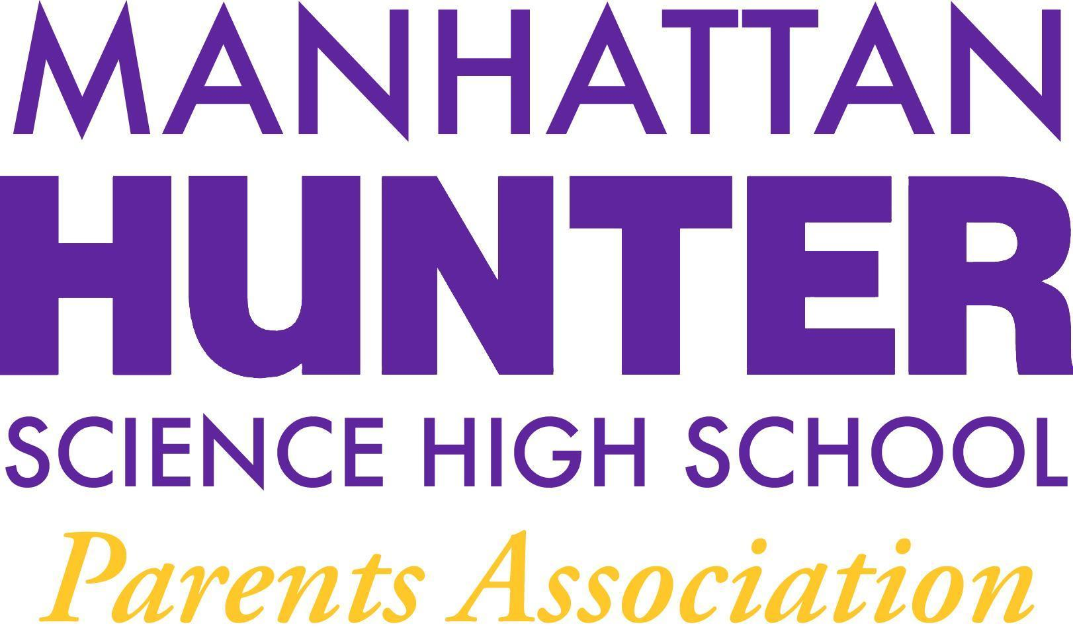
AGENDA
Manhattan Hunter Science High School Parents Association
General Membership Meeting
Tuesday, December 21, 2021
5:30pm-6:30pm (Via Zoom)

- Meeting call to Order
- Approval October and November 2021 Minutes Approval
- Monthly Financials Review
  - Income
    - “From Thanks to Love” - we reached our goal! ($2500 + match - increasing to $3500!)
  - Upcoming/Recent Expenses
    - Gershon Retirement Party (food and beverage) $400
    - Class Mixers (food and beverage) total for all - 6 (2 per grade) - $6,500
    - Skateboard Racks (2 racks/8 boards) $1,000
    - 3 new Keyboards $1,000
    - Holiday Party - $2,000 (and volunteers needed)
      - Door Decorating Kits - $250
      - Pizza (Dominos- $1,000 (800 slices)
      - Gift cards - $275
      - Water and chips for the movie - $415
    - Young Men’s Empowerment Group - $1,000
    - Uniforms - $250
- PA Announcements
  - Shout out to decorations volunteers!
  - 24 Hour Assignment Rule
  - Amazon Smile Shopping Reminder
  - Website Design Committee - parent, student and teacher input
  - Spring Fling! (Online Auction)
- Q&A with Dr. Froner

