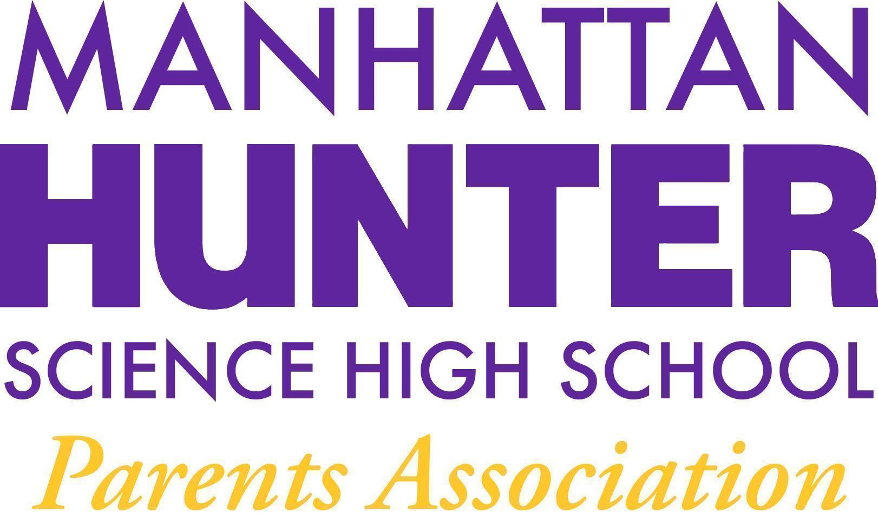
AGENDA
Manhattan Hunter Science High School Parents Association
General Membership Meeting
Tuesday, April 26, 2022
05:30pm (Via Zoom)

The Meeting was called to order at 5:34pm

AP Pam Wilks made a presentation on Junior Year Preparations for College (see the presentation for details)

The March 2022 Meeting Minutes were approved by a show of hands

Monthly Financials Review
- The PA EB presented the budget to actuals to the members - the summary is below
- Members voted on a $1500 + 600 (t-shirts) budget for the Botany club and the budget was approved by a show of hands

The following PA Announcements were discussed:
- Our PA Executive Board and SLT Elections will take place on 17 May 2022
- The students have collected $500 for Ukraine Giving
- Financial Literacy Course Update - tabled
- Culinary Club/Cooking Club - will restart in September 2022
- Our committee gave an update on the bathroom leaks and flushing issues and will follow up with Dr. Froner on bathroom vaping for the May 2022 mtg
- The school will host a homecoming/End of Year Celebration - Senior Symposium and the PA will provide food. Budget TBD
- The Website Design Committee continues its work on upgrading/updating the website - all input is welcome.

Meeting Adjourned at 6:15pm

Executive Board - Slate - 2022/2023
Heather Tait - President
Barry Daub - VP (Hunter College Liaison)
Shari Hoenig - VP
Kristen Berger - Recording Secretary
Rachel Spiers - Treasurer

