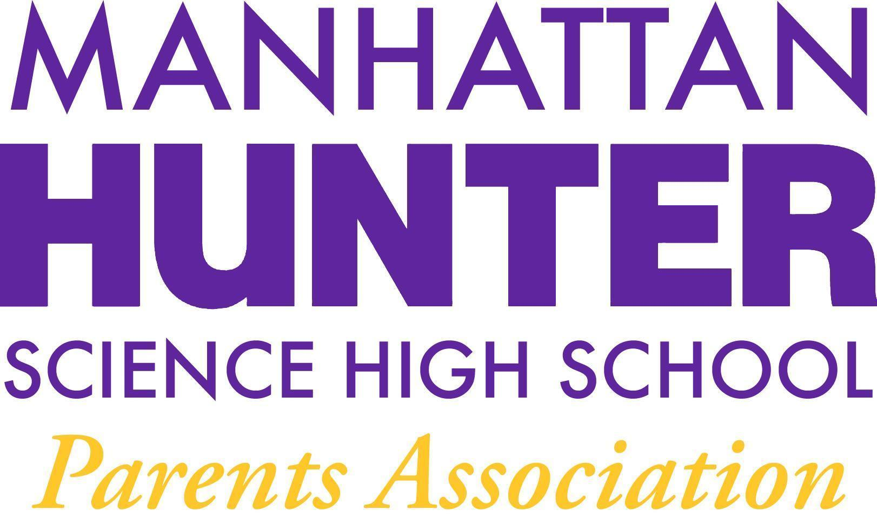
NOTES
Manhattan Hunter Science High School Parents Association
General Membership Meeting
Tuesday, December 21, 2021
5:30pm-6:30pm (Via Zoom)

- Meeting was called to order at 06:35pm
- Approval October and November 2021 Minutes Approval - was tabled until January 2021
- Monthly Financials Review
  - “From Thanks to Love” - we reached our goal of $2500 + match - increasing our fundraising goal to $3500 and a new fundraising email will go out over the holidays.
  - Recent Expenses - instead of the usual line item budget, the members voted in May and September to earmark discretionary funds for the school to use and the EB board to approve at its discretion. Monies spent to be reported monthly to Members for their feedback. (see agenda for details)
  - Young Men’s Empowerment Group
    - A parent asked about the Young Women’s Empowerment Group budget and if there should be a group for non-binary students. The PA will invite Marilyn Arias to update the PA on the groups at the January 2022 meeting.
    - Uniforms - the PA has earmarked funds so students can always have uniforms if needed.
- PA Announcements
  - Shout out to decorations volunteers - the school looks beautiful and Chrsitmas, Kwanzaa and Hanukah are all represented
  - 24 Hour Assignment Rule - teachers were reminded that all out of class assignments (even in class assignments that are converted to homework) must be due at least 24 hours from the day/time assigned. If parents find this is not the case, please reach out to Mr. Sinchi or your student’s teacher directly.
  - Amazon Smile Shopping Reminder - please use Amazon Smile for MHSHS when you are doin your shopping. The school receives a small percentage of what you purchase and every little bit helps.
  - Website Design Committee - looking for parent, student and teacher input - the first meeting will be in mid-January - please reach out to the PA if you can help.
  - Spring Fling! (Online Auction) - sneak preview! The Spring Fling will be our major fundraiser in the Spring for Spring school activities
- Q&A with Dr. Froner
  - Students attendance and academics should be applauded - our students remain on track and are a strong academic community.
  - Dr. Froner has not heard anything specifically about the campus closing due to an uptick in Covid-19 cases.
  - The Holiday Party is scaled back and will only be pizza and individual classroom activities.
  - Masks are required and any parents who know of classrooms where students are not complying should reach out to Dr. Froner to address.
  - If parents choose to keep students home at this point, teachers have been instructed to be lenient with work deadlines and help students manage assignments from home.
  - Tik Tok Threats of Violence
    - MLK is a scanning building with a large police/security presence
    - Students are safe and being supported on campus
    - Parents are encouraged to speak to their children about the power of social media and how it can anesthetize students to actions and consequences.

  - Senior Class updates
    - Hunter college may extend their break or go remote after the holidays - students will take their HS classes at MLK
    - Seniors have been asked to act as mentors to junior classmen
    - A senior mixer (or 2) will be added to the existing PA budget.

